# Istio Lab 2

## Traffic Shifting

### Defining Service Versions



Showing dest rules:

### Routing rating traffic to V1 version:

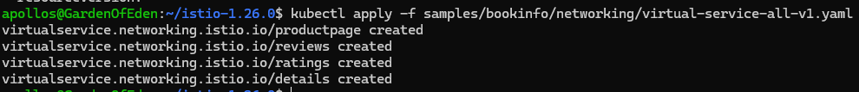

Proof ratings can no longer be seen:

Routing 50% of traffic:



Proof:

Routing all traffic to V3:



Cleanup:



## Request Routing

Creating routing rules:

Verifying:

Matching end user to see reviews:

## Fault Injection

Timing delay applied:



Proof the delay works:

Applying abort rules:

Testing:

## Circuit Breaking

Preconfig:



Applying Circuit Breaking to rules:

Deploying Fortio:

Request Successful:

Proof of circuit breaking working:

